**Digital Marketing Assignment -1**

|  |  |
| --- | --- |
| Student Name | Anna Lakshmi A |
| Student Register Number | 953720104006 |
| College Name | AAA College of Engineering and Technology |
| Naan Mudhalvan ID | CB8FDE3526945B59D454EE59062C6DE0 |

**Assignment:**

Create a blog or website using Blogpost and WordPress. Customize the theme design and post new article with 500 words.

**Solution:**

1.BlogPost

Link: <https://karukumorukusweets.blogspot.com/2023/08/karuku-moruku-sweets.html>

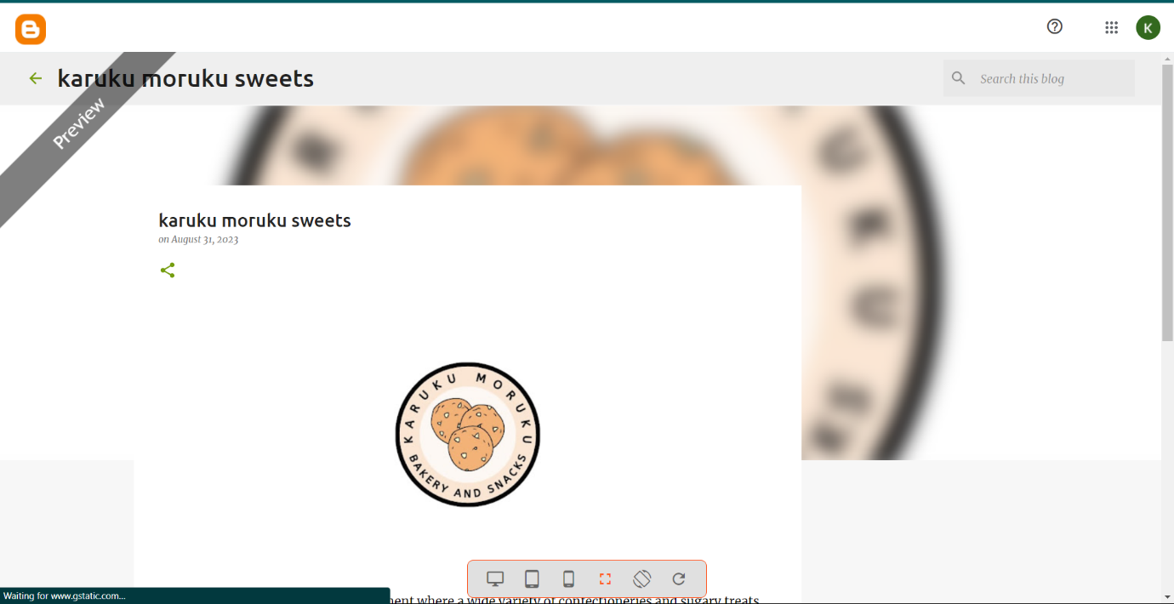

2.WordPress

Link<https://karukumorukusweets.wordpress.com/2023/10/29/karuku-moruku-sweets/>